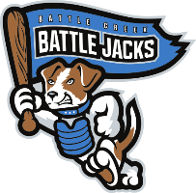**STAT SHEET**

**July 26, 2022 vs. Kenosha Kingfish**

**Battle Creek Battle Jacks Roster (24-28)**



**Second Half Standings**



**Jacks Spotlight**



**League Leaders**



**Lineup**

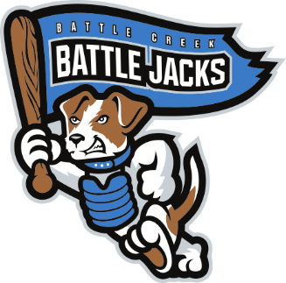

For more player and team statistics, make sure to grab an Advanced Stats sheet from Guest Services near the main entrance.

Thank you, and gooooooo Battle Jacks!!!